PRACTICAL- 1

Aim: – Outlier Removal from with help of Z-Score.

Code-

# importing lib
In [1]:
import pandas as pd
import seaborn as sn
In [2]:
df = pd.read_csv("D:\weight-height.csv")
df.head()
Out[2]:
 | Gender | Height | Weight
0 | Male | 73.847017 | 241.893563
1 | Male | 68.781904 | 162.310473
2 | Male | 74.110105 | 212.740856
3 | Male | 71.730978 | 220.042470
4 | Male | 69.881796 | 206.349801
In [3]:
df= df.drop('Weight',axis=1)
In [4]:
df.head()
Out[4]:
 | Gender | Height
0 | Male | 73.847017
1 | Male | 68.781904
2 | Male | 74.110105
3 | Male | 71.730978
4 | Male | 69.881796
In [15]:
df.shape
Out[15]:
(10000, 2)
In [18]:
df.Height.describe()
Out[18]:
count 10000.000000
mean 66.367560
std 3.847528
min 54.263133
25% 63.505620
50% 66.318070
75% 69.174262
max 78.998742
Name: Height, dtype: float64
In [20]:
sn.histplot(df.Height, kde=True)
Out[20]:
<AxesSubplot:xlabel='Height', ylabel='Count'>
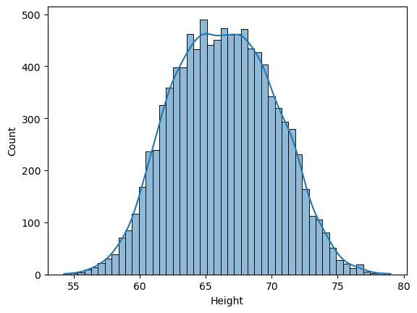
In [22]:
mean = df.Height.mean()
mean
Out[22]:
66.3675597548656
In [24]:
std_deviation = df.Height.std()
std_deviation
Out[24]:
3.847528120795573
In [25]:
mean - 3*std_deviation
Out[25]:
54.824975392478876
In [26]:
mean + 3*std_deviation
Out[26]:
77.91014411725232
In [27]:
df[df.Height<54.82]
Out[27]:
 | Gender | Height
6624 | Female | 54.616858
9285 | Female | 54.263133
In [29]:
df[(df.Height<54.82)|(df.Height>77.91)]
Out[29]:
 | Gender | Height
994 | Male | 78.095867
1317 | Male | 78.462053
2014 | Male | 78.998742
3285 | Male | 78.528210
3757 | Male | 78.621374
6624 | Female | 54.616858
9285 | Female | 54.263133
In [30]:
78.9987/12
Out[30]:
6.583225

In [34]:
df_no_outliers = df[(df.Height>54.82) & (df.Height<77.91)]
df_no_outliers.shape
Out[34]:
(9993, 2)
In [35]:
df.head(5)
Out[35]:
 | Gender | Height
0 | Male | 73.847017
1 | Male | 68.781904
2 | Male | 74.110105
3 | Male | 71.730978
4 | Male | 69.881796

Z Score: How many Standard deviation away a datapoints is from mean.
In [37]:
df['zscore'] = (df.Height - df.Height.mean()) / df.Height.std()
df.head()
Out[37]:
 | Gender | Height | zscore
0 | Male | 73.847017 | 1.943964
1 | Male | 68.781904 | 0.627505
2 | Male | 74.110105 | 2.012343
3 | Male | 71.730978 | 1.393991
4 | Male | 69.881796 | 0.913375
In [38]:
df.Height.mean()
Out[38]:
66.3675597548656
In [39]:
df.Height.std()
Out[39]:
3.847528120795573
#Z score for first entry
In [40]:
(73.847017-66.3675597548656)/3.847528120795573
Out[40]:
1.943964283122077
In [41]:
df[df.zscore<-3]
Out[41]:
 | Gender | Height | zscore
6624 | Female | 54.616858 | -3.054091
9285 | Female | 54.263133 | -3.146027
In [43]:
df[(df.zscore<-3)|(df.zscore>3)]
Out[43]:
 | Gender | Height | zscore
994 | Male | 78.095867 | 3.048271
1317 | Male | 78.462053 | 3.143445
2014 | Male | 78.998742 | 3.282934
3285 | Male | 78.528210 | 3.160640
3757 | Male | 78.621374 | 3.184854
6624 | Female | 54.616858 | -3.054091
9285 | Female | 54.263133 | -3.146027

PRACTICAL- 2

Aim – Creating a Liner Regression Model for Property Price Prediction with Multiple Variable.

Code-
import pandas as pd
import numpy as np
import matplotlib.pyplot as plt
from sklearn import linear_model
In [2]:
df = pd.read_csv("D:\home price prediction MV.csv")
df
Out[2]:
 | area | bedroom | age | price
0 | 2600 | 3.0 | 20 | 550000
1 | 3000 | 4.0 | 15 | 565000
2 | 3200 | NaN | 18 | 610000
3 | 3600 | 3.0 | 30 | 595000
4 | 4000 | 5.0 | 8 | 760000

In [4]:
df.bedroom.median()
Out[4]:
3.5

want to keep this integer so will call maths function
In [7]:
import math
median_bedroom = math.floor(df.bedroom.median(
median_bedroom = math.floor(df.bedroom.median())
median_bedroom
Out[7]:
3
In [9]:
df.bedroom.fillna(median_bedroom)
Out[9]:
0 3.0
1 4.0
2 3.0
3 3.0
4 5.0
Name: bedroom, dtype: float64
In [10]:
df.bedroom = df.bedroom.fillna(median_bedroom)
df
Out[10]:
 | area | bedroom | age | price
0 | 2600 | 3.0 | 20 | 550000
1 | 3000 | 4.0 | 15 | 565000
2 | 3200 | 3.0 | 18 | 610000
3 | 3600 | 3.0 | 30 | 595000
4 | 4000 | 5.0 | 8 | 760000
In [11]:
reg = linear_model.LinearRegression()
reg.fit(df[['area','bedroom','age']],df.price)
Out[11]:
LinearRegression()
In [12]:
reg.coef_
Out[12]:
array([ 137.25, -26025. , -6825. ])
In [13]:
reg.intercept_
Out[13]:
383724.9999999998
In [14]:
reg.predict([[3000,3,40]])
C:\Users\Gaurav\anaconda3\lib\site-packages\sklearn\base.py:450: UserWarning: X does not have valid feature names, but LinearRegression was fitted with feature names
warnings.warn(
array([444400.])
In [15]:
reg.predict([[3000,3,15]])
C:\Users\Gaurav\anaconda3\lib\site-packages\sklearn\base.py:450: UserWarning: X does not have valid feature names, but LinearRegression was fitted with feature names
warnings.warn(
Out[15]:
array([615025.])
price = m1 area + m2bedrooms + m3* age + b(intercept)
In [17]:
pr = 137.25*3000+-26025.*3+-6825.*40+383724.9999999998
pr
Out[17]:
444399.9999999998

PRACTICAL- 3

Aim – Installation of Single node Hadoop cluster on Ubuntu.

THEORY:
Apache Hadoop 3.1 have noticeable improvements any many bug fixes over the previous stable
3.0 releases. This version has many improvements in HDFS and MapReduce. This how-to guide will help you to setup Hadoop 3.1.0 Single-Node Cluster on CentOS/RHEL 7/6/5, Ubuntu 18.04, 17.10, 16.04 & 14
.04, Debian 9/8/7 and LinuxMint Systems. This article has been tested with Ubuntu 18.04 LTS.

Prerequisites
Java is the primary requirement for running Hadoop on any system, So make sure you have Java installed on your system using the following command. If you don’t have Java installed on your system, use one of the following links to install it first. Hadoop supports only JAVA 8 If already any other version is present then uninstall the following using these commands.
sudo apt-get purge openjdk-\* icedtea-\* icedtea6-\* OR
sudo apt remove openjdk-8-jdk

Step 1.1 – Install Oracle Java 8 on Ubuntu
You need to enable additional repository to your system to install Java 8 on Ubuntu VPS. After that install Oracle Java 8 on an Ubuntu system using apt-get.This repository contains a package named oracle-java8-installer, Which is notan actual Java package. Instead of that, this package contains a script toinstall Java on Ubuntu.Run below commands to install Java 8 on Ubuntu and LinuxMint.
sudo add-apt-repository ppa:webupd8team/java sudo apt-get sudo apt-get install oracle-java8-installer OR
sudo apt install openjdk-8-jre-headless sudo apt install openjdk-8-jdk

Step 1.2 – Verify Java Inatallation
The apt repository also provides package oracle-java8-set-default to set Java 8 as your default Java version. This package will be installed along with Java installation. To make sure run below command.
sudo apt-get install oracle-java8-set-default

After successfully installing Oracle Java 8 using the above steps, Let’s verify the installed version using the following command.
java -version
java version "1.8.0_201"

Java(TM) SE Runtime Environment (build 1.8.0_201-b09)
Java HotSpot(TM) 64-Bit Server VM (build 25.201-b09, mixed mode)

Step 1.3 – Setup JAVA_HOME and JRE_HOME Variable
Add the java path to JAVA_HOME variable in .bashrc file. Go to your home directory and in the folder option click on show hidden files. After that a .bashrc file will be present, open the file and add the following line at the end.
NOTE- Path of the java will be your pc path on which java is been installed. export JAVA_HOME=/usr/lib/jvm/java-8-oracle
NOTE- After doing all changes and saving the file run the following command to make changes through the .bashrc file.
source ~/.bashrc
All done, you have successfully installed Java 8 on a Linux system.

Create Hadoop User
We recommend creating a normal (nor root) account for Hadoop working. To create an account using the following command.
adduser hadoop passwd hadoop
Set up a new user for Hadoop working separately other than the normal users.
NOTE- Its compulsory to create a sperate user with username hadoop otherwise it may give you path file issues later.
Also run these commands from an admin privileged user present on the machine. sudo adduser Hadoop sudo
Command – sudo adduser hadoop sudo If you have already created the user and want to give sudo/root privileges to it then run the following command.
sudo usermod -a -G sudo hadoop
Otherwise you can directly edit the permission lines in sudoers file. Go to the root access by running
sudo -I or su- <username>
Type the following command and add the below line to the file. visudo
Add following lines to the file. hadoop ALL=(ALL:ALL) ALL
After creating the account, it also required to set up key-based ssh to its own account. To do this use execute following commands.
su - hadoop
ssh-keygen -t rsa -P '' -f ~/.ssh/id_rsa
cat ~/.ssh/id_rsa pub >> ~/.ssh/authorized_keys chmod 0600 ~/.ssh/authorized_keys
Let’s verify key based login. Below command should not ask for the password but the first time it will prompt for adding RSA to the list of known hosts.
ssh localhost exit
Disable all firewall restriction sudo ufw disable
If above command doesn’t work then go with. service iptables stop
OR
sudo chkconfig iptables off
Sometimes it’s better to manage firewall using a third party software. Ex. yast

Download Hadoop 3.1 Archive
In this step, download hadoop 3.1 source archive file using below command. You can also select alternate download mirror for increasing download speed.
cd ~
wget http://www-eu.apache.org/dist/hadoop/common/hadoop-3.1.0/hadoop-3.1.0.tar.gz tar xzf hadoop-3.1.0.tar.gz
mv hadoop-3.1.0 hadoop

Setup Hadoop Pseudo-Distributed Mode
  - Setup Hadoop Environment Variables
First, we need to set environment variable uses by Hadoop. Edit ~/.bashrc file and append following values at end of file.
export HADOOP_HOME=/home/hadoop/hadoop export HADOOP_INSTALL=$HADOOP_HOME export HADOOP_MAPRED_HOME=$HADOOP_HOME export HADOOP_COMMON_HOME=$HADOOP_HOME export HADOOP_HDFS_HOME=$HADOOP_HOME
export YARN_HOME=$HADOOP_HOME
export HADOOP_COMMON_LIB_NATIVE_DIR=$HADOOP_HOME/lib/native export PATH=$PATH:$HADOOP_HOME/sbin:$HADOOP_HOME/bin
Now apply the changes in the current running environment source ~/.bashrc

Now edit $HADOOP_HOME/etc/hadoop/hadoop-env.sh file and set JAVA_HOME environment variable. Change the JAVA path as per install on your system. This path may vary as per your operating system version and installation source. So make sure you are using correct path. export JAVA_HOME=/usr/lib/jvm/java-8-oracle

Setup Hadoop Configuration Files
Hadoop has many of configuration files, which need to configure as per requirements of your Hadoop infrastructure. Let’s start with the configuration with basic Hadoop single node cluster setup. first, navigate to below location
cd $HADOOP_HOME/etc/hadoop Edit core-site.xml
<configuration>
<property>
<name>fs.default.name</name>
<value>hdfs://localhost:9000</value>
</property>
</configuration>

Edit hdfs-site.xml
<configuration>
<property>
<name>dfs.replication</name>
<value>1</value>
</property>
<property>
<name>dfs.name.dir</name>
<value>file:///home/hadoop/hadoopdata/hdfs/namenode</value>
</property>
<property>
<name>dfs.data.dir</name>
<value>file:///home/hadoop/hadoopdata/hdfs/datanode</value>
</property>
</configuration>

Edit mapred-site.xml
<configuration>
<property>
<name>mapreduce.framework.name </name>
<value>yarn </value>
</property>
</configuration>

Edit yarn-site.xml
<configuration>
<property>
<name>yarn.nodemanager.aux-services </name>
<value>mapreduce_shuffle </value>
</property>
</configuration>

Format Namenode
Now format the namenode using the following command, make sure that Storage directory is hdfs namenode -format

Sample output:
WARNING: /home/hadoop/hadoop/logs does not exist. Creating.
2018-05-02 17:52:09,678 INFO namenode.NameNode: STARTUP_MSG:
STARTUP_MSG: Starting NameNode STARTUP_MSG: host = localhost/127.0.1.1
STARTUP_MSG: args = [-format] STARTUP_MSG: version = 3.1.0
...
...
...
2018-05-02 17:52:13,717 INFO common.Storage: Storage directory
/home/hadoop/hadoopdata/hdfs/namenode has been successfully formatted.
2018-05-02 17:52:13,806 INFO namenode.FSImageFormatProtobuf: Saving image file
/home/hadoop/hadoopdata/hdfs/namenode/current/fsimage.ckpt_0000000000000000000 using no
compression
2018-05-02 17:52:14,161 INFO namenode.FSImageFormatProtobuf: Image file
/home/hadoop/hadoopdata/hdfs/namenode/current/fsimage.ckpt_0000000000000000000 of size 391 bytes saved in 0 seconds .
2018-05-02 17:52:14,224 INFO namenode.NNStorageRetentionManager: Going to retain 1 images with txid >= 0
2018-05-02 17:52:14,282 INFO namenode.NameNode: SHUTDOWN_MSG:
/************************************************************ SHUTDOWN_MSG: Shutting down NameNode at localhost/127.0.1.1
************************************************************/

Start Hadoop Cluster
Let’s start your Hadoop cluster using the scripts provides by Hadoop. Just navigate to your $HADOOP_HOME/sbin directory and execute scripts one by one.
Cd $HADOOP_HOME/sbin/

Now run start-dfs.sh script.
./start-dfs.sh
Sample output:Starting namenodes on [localhost] Starting datanodes
Starting secondary namenodes [localhost]
2018-05-02 18:00:32,565 WARN util.NativeCodeLoader: Unable to load native-hadoop library for your platform... using builtin-java classes where applicable
Now run start-yarn.sh script.
./start-yarn.sh
Sample output:Starting resourcemanager Starting nodemanagers

Hadoop NameNode started on port 9870 default. Access your server on port 9870 in your favorite web browser.
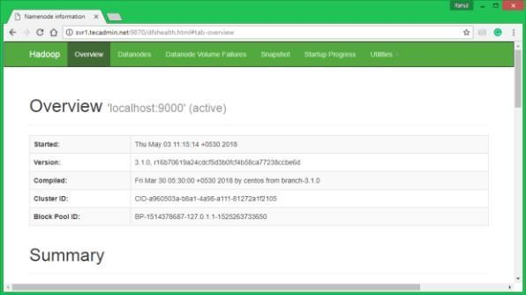
http://localhost:9870/

Now access port 8042 for getting the information about the cluster and all applications http:// localhost:8042/
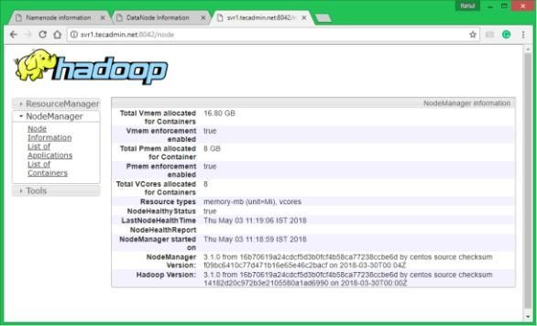
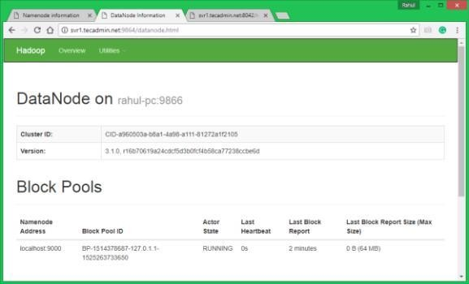
Access port 9864 to get details about your Hadoop node. http://localhost:9864/

Test Hadoop Single Node Setup
  - Make the HDFS directories required using following commands.
bin/hdfs dfs -mkdir /user bin/hdfs dfs -mkdir /user/hadoop

Copy all files from local file system /var/log/httpd to hadoop distributed file system using below command
bin/hdfs dfs -put /var/log/apache2 logs

Browse Hadoop distributed file system by opening below URL in the browser. You will see an apache2 folder in the list.
http://localhost:9870/explorer.html#/user/hadoop/logs/

PRACTICAL- 4

Aim – Hadoop programming: Word count map reduce program using Eclipse.

THEORY:
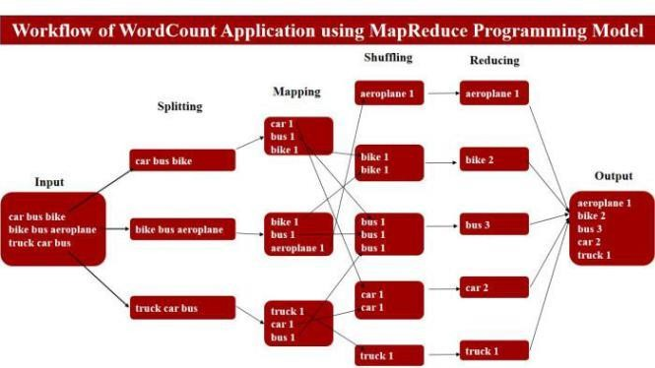

Steps to run WordCount Application in Eclipse

Step-1
Download eclipse if you don’t have. 64 bit Linux os 32 bit Linux os

Step-2
Open Eclipse and Make Java Project.
In eclipse Click on File menu-> new -> Java Project. Write there your project name. Here is WordCount. Make sure Java version must be 1.6 and above. Click on Finish.
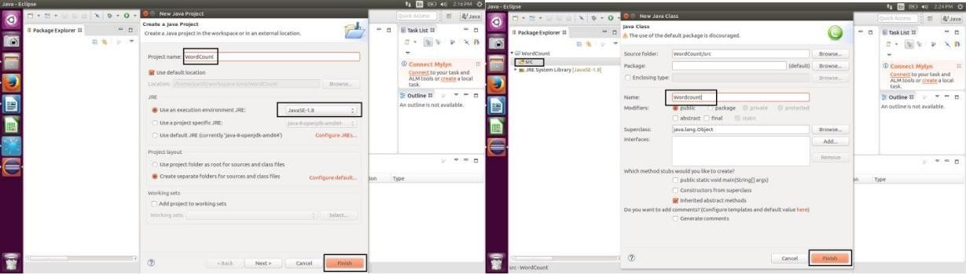

Step-3
Make Java class File and write a code.
Click on WordCount project. There will be ‘src’ folder. Right click on ‘src’ folder -> New -> Class. Write Class file name. Here is Wordcount. Click on Finish.

Copy and Paste below code in Wordcount.java. Save it.
You will get lots of error but don’t panic. It is because of requirement of external library of hadoop which is required to run mapreduce program.

import java.io.IOException; import java.util.StringTokenizer;
import org.apache.hadoop.conf.Configuration; import org.apache.hadoop.fs.Path;
import org.apache.hadoop.io.IntWritable; import org.apache.hadoop.io.Text;
import org.apache.hadoop.mapreduce.Job; import org.apache.hadoop.mapreduce.Mapper; import org.apache.hadoop.mapreduce.Reducer;
import org.apache.hadoop.mapreduce.lib.input.FileInputFormat; import org.apache.hadoop.mapreduce.lib.output.FileOutputFormat; public class Wordcount {
public static class TokenizerMapper extends Mapper{
private final static IntWritable one = new IntWritable(1); private Text word = new Text();
public void map(Object key, Text value, Context context) throws IOException, InterruptedException {
StringTokenizer itr = new StringTokenizer(value.toString()); while (itr.hasMoreTokens()) {
word.set(itr.nextToken()); context.write(word, one);
}
}
}
public static class IntSumReducer extends Reducer {
private IntWritable result = new IntWritable();
public void reduce(Text key, Iterable values,Context context) throws IOException, InterruptedException {
int sum = 0;
for (IntWritable val : values) { sum += val.get();
}
result.set(sum); context.write(key, result);
}
}
public static void main(String[] args) throws Exception
{ Configuration conf = new Configuration(); Job job = Job.getInstance(conf, "word count"); job.setJarByClass(WordCount.class); job.setMapperClass(TokenizerMapper.class); job.setCombinerClass(IntSumReducer.class); job.setReducerClass(IntSumReducer.class); job.setOutputKeyClass(Text.class); job.setOutputValueClass(IntWritable.class);
FileInputFormat.addInputPath(job, new Path(args[0])); FileOutputFormat.setOutputPath(job, new Path(args[1])); System.exit(job.waitForCompletion(true) ? 0 : 1);
}
}

Step-4
Add external libraries from hadoop.
Right click on WordCount Project -> Build Path -> Configure Build Path -> Click on Libraries -
> click on ‘Add External Jars..’ button.

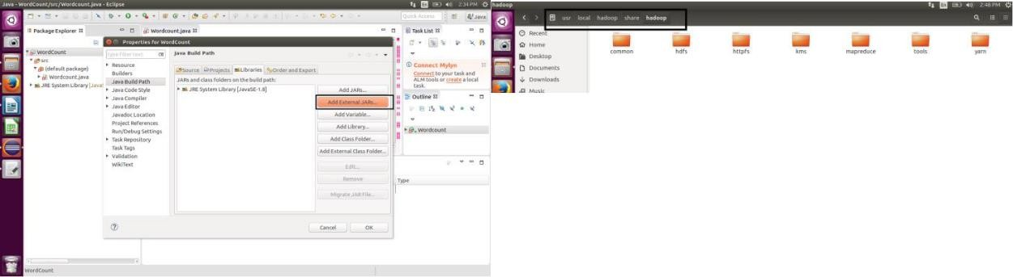

Select below files from hadoop folder.
In my case:- /usr/local/hadoop/share/hadoop
  - Add jar files from /usr/local/hadoop/share/hadoop/common folder.

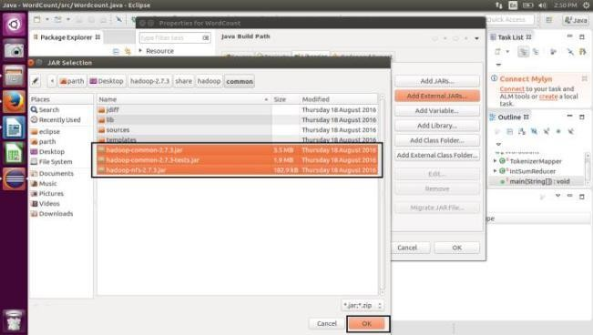
  - Add jar files from /usr/local/hadoop/share/hadoop/common/lib folder.
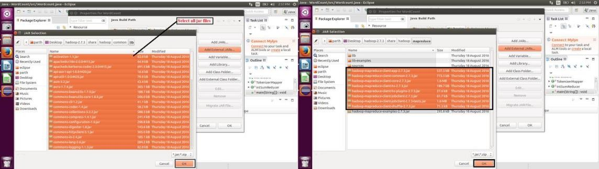
  - Add jar files from /usr/local/hadoop/share/hadoop/mapreduce folder (Don’t need to add hadoop-mapreduce-examples-2.7.3.jar)

  - Add jar files from /usr/local/hadoop/share/hadoop/yarn folder.

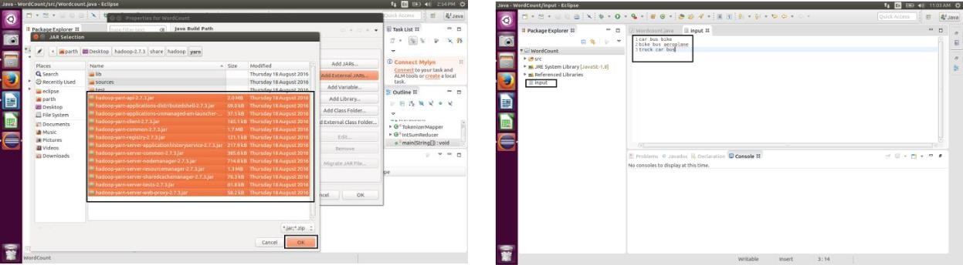

Click on ok. Now you can see, all error in code is gone.

Step 5
Running Mapreduce Code.
  - Make input file for WordCount Project.
Right Click on WordCount project-> new -> File. Write File name and click on ok. You can copy and paste below contains into your input file.
car bus bike
bike bus aeroplane truck car bus
  - Right click on WordCount Project -> click on Run As. -> click on Run Configuration… Make new configuration by clicking on ‘new launch configuration’. Set Configuration Name, Project Name and Class file name.

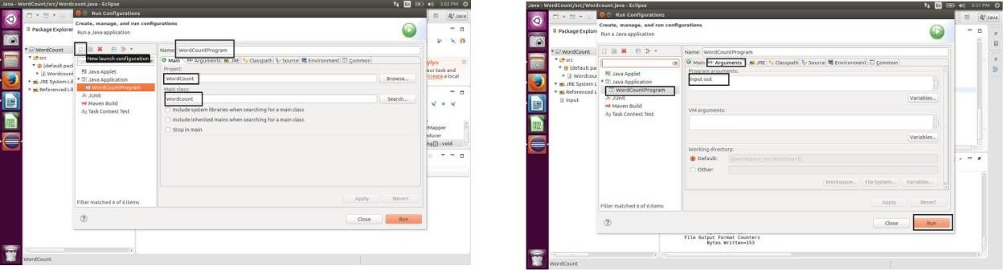

Output of WordCount Application and output logs in console.
Refresh WordCount Project. Right Click on project -> click on Refresh. You can find ‘out’ directory in project explorer. Open ‘out’ directory. There will be ‘part-r-00000’ file. Double click to open it.
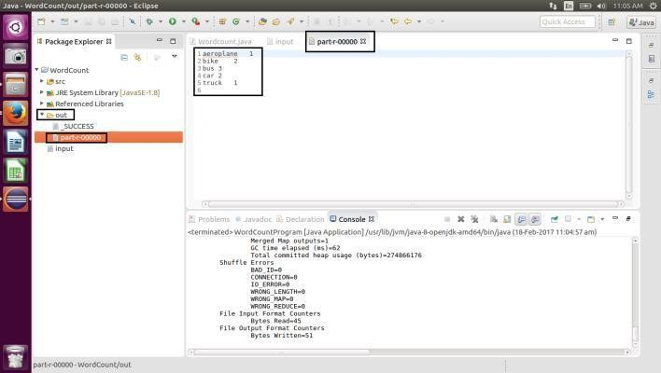

PRACTICAL- 5

Aim – Implementing Clustering algorithm using Map-reduce.

THEORY:
MapReduce runs as a series of jobs, with each job essentially a separate Java application that goes out into the data and starts pulling out information as needed. Based on the MapReduce design, records are processed in isolation via tasks called Mappers. The output from the Mapper tasks is further processed by a second set of tasks, the Reducers, where the results from the different Mapper tasks are merged together. The Map and Reduce functions of MapReduce are both defined with respect to data structured in (key, value) pairs. Map takes one pair of data with a type in one data domain, and returns a list of pairs in a different domain:
Map(k1,v1) → list(k2,v2)
The Map function is applied in parallel to every pair in the input dataset. This produces a list of pairs for each call. After that, the MapReduce framework collects all pairs with the same key from all lists and groups them together, creating one group for each key. The Reduce function is then applied in parallel to each group, which in turn produces a collection of values in the same domain: Reduce(k2, list (v2)) → list(v3)
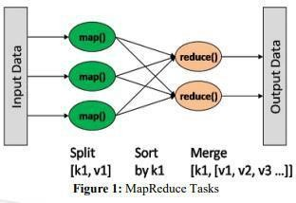

Algorithm for Mapper
Input: A set of objects X = {x1, x2…xn}, A Set of initial Centroids C = {c1, c2, ,ck}
Output: An output list which contains pairs of (Ci, xj)where 1 ≤ i≤ n and 1 ≤j ≤ k
Procedure M1←{x1, x2… xm}
current_centroids←C
Distance (p, q) =√Σdi=1(pi– qi)2 (where pi (or qi)is the coordinate of p (or q) in dimension
i) for all xi ϵ M1 such that 1≤i≤m do bestCentroid←null minDist←∞
for all c ϵ current_centroids do

dist← distance (xi, c)
if (bestCentroid = null || dist<minDist)
then
minDist←dist
bestCentroid ← c
end if
end for
emit (bestCentroid, xi)
i+=1
end for
return Outputlist

Algorithm for Reducer
Input: (Key, Value), where key = bestCentroid and Value
=Objects assigned to the lpgr'; 1\] x centroid by the mapper
Output: (Key, Value), where key = oldCentroid and value =
newBestCentroid which is the new centroid value
calculated for that best Centroid
Procedure
Outputlist←outputlist from mappers
← { }
New Centroid List ← null
for all β output list do
centroid ←β.key
object ←β.value
[centroid] ← object
end for
for all centroid ϵ do
new Centroid, sum of Objects,
sum of Objects← null
for all object ϵb[centroid] do
sum of Objects += object
num of Objects += 1
end for
newCentroid ← (sumofObjects +
num of Objects)
emit (centroid, newCentroid)
end for
end
The outcome of the k-means map reduce algorithm is the cluster points along with bounded documents as <key, value> pairs, where key is the cluster id and value contains in the form of vector: weight. The weight indicates the probability of vector be a point in that cluster. For Example: Key: 92: Value: 1.0: [32:0.127,79:0.114, 97:0.114, 157:0.148 ...].
The final output of the program will be the cluster name, filename: number of text documents that belong to that cluster

PRACTICAL- 6

Aim – Write queries to sort and aggregate data in a table using HiveQL

THEORY:
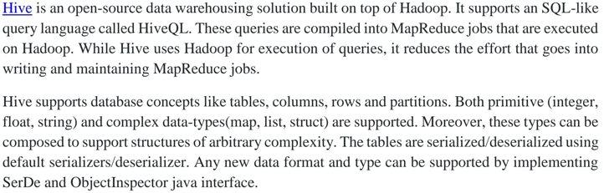

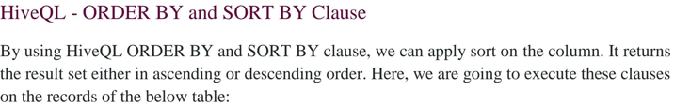

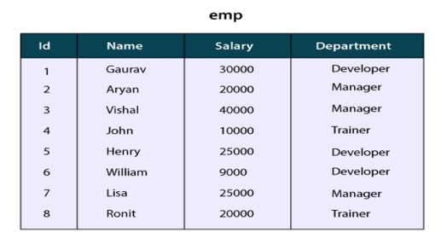

HiveQL- Order by Clause

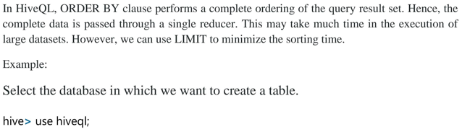

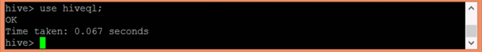
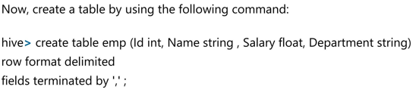
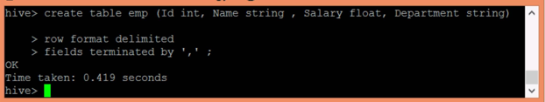


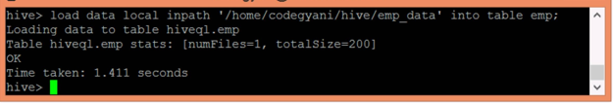


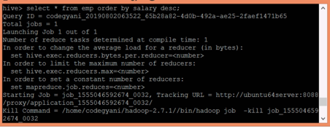
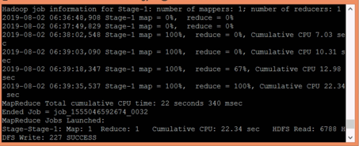

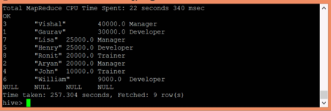

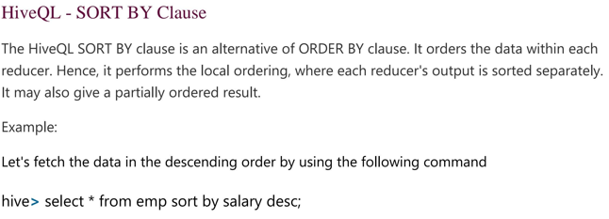

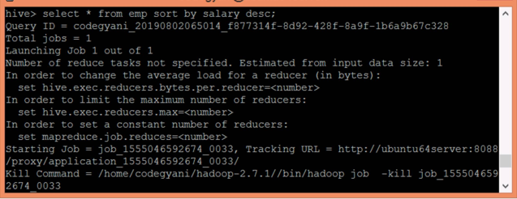

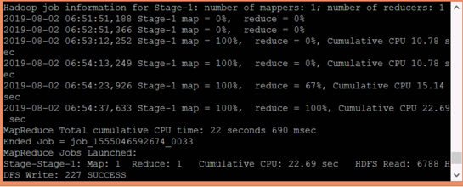

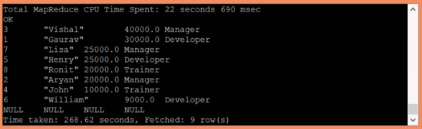

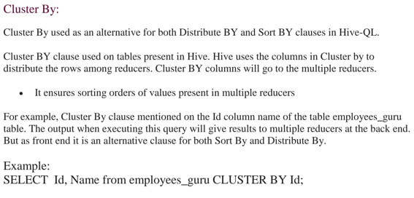

Result:

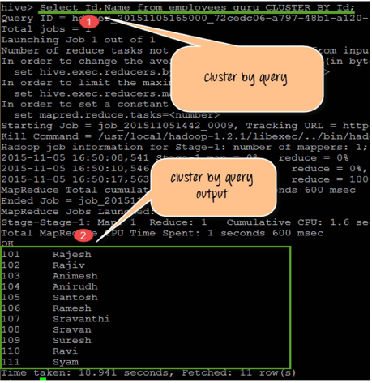

PRACTICAL- 7

Aim –T- Test performing Hypothesis Testing.

THEORY:
Introduction:-Hypothesis testing is important in statistics because it gives statistical evidence to show the validity of the study. The null hypothesis states that there is no statistical significance exists between sets of data which implies that the population parameter will be equal to a hypothesized value. Usually, We state the alternative hypothesis which we want to prove. For a null hypothesis H₀ and its complementary alternative hypothesis H₁, there are 3 cases when the parametric value under H₀ ≠ H₁ or H₀ < H₁ or H₀ > H₁.
Let’s consider a scenario where I have stated the hypothesis, a relevant test statistic, and the Python code for your understanding. I have coded the conclusion part too. Here, I have shared with you few cases instead of covering all. In this blog, I would like to give examples for one sample t-test, two-sample t-test, and paired t-test using Python.

One sample t-test Data:
Systolic blood pressures of 14 patients are given below:
183, 152, 178, 157, 194, 163, 144, 114, 178, 152, 118, 158, 172, 138
Test, whether the population mean, is less than 165

Hypothesis:
H₀: There is no significant mean difference in systolic blood pressure. i.e., μ = 165
H₁: The population mean is less than 165. i.e., μ < 165

Test statistic
Where,
x̄ is sample mean
μ is the population mean
s is sample standard deviation
n is the number of observations;
Code:-
ys_bp=[183, 152, 178, 157, 194, 163, 144, 114, 178, 152, 118, 158, 172, 138
mu=165
from scipy import stats
t_value,p_value=stats.ttest_1samp(sys_bp,mu)
one_tailed_p_value=float("{:.6f}".format(p_value/2)) # Since alternative hypothesis is one tailed, We need to divide the p value by 2.
print('Test statistic is %f'%float("{:.6f}".format(t_value)))
print('p-value for one tailed test is %f'%one_tailed_p_value)
alpha = 0.05
if one_tailed_p_value<=alpha:
print('Conclusion','n','Since p value(=%f)'%p_value,'<','alpha(=%.2f)'%alpha,'''We reject the null hypothesis H0. So we conclude that there is no significant mean difference in systolic blood pressure. i.e., μ = 165 at %.2f level of significance'''%alpha)
else:
print('Conclusion','n','Sincep-value(=%f)'%one_tailed_p_value, '>', 'alpha(=%.2f)'%alpha,'We do not reject the null hypothesis H0.')

